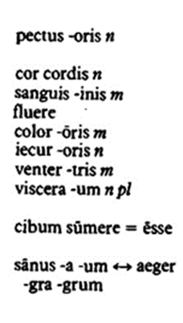
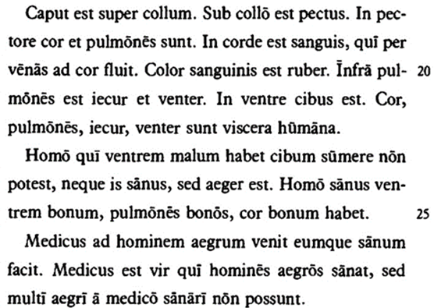
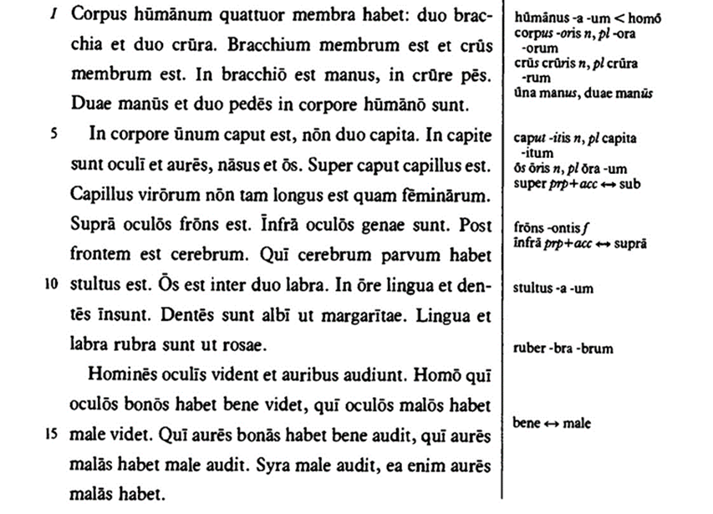
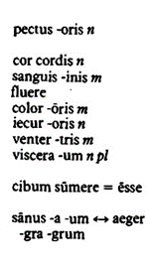
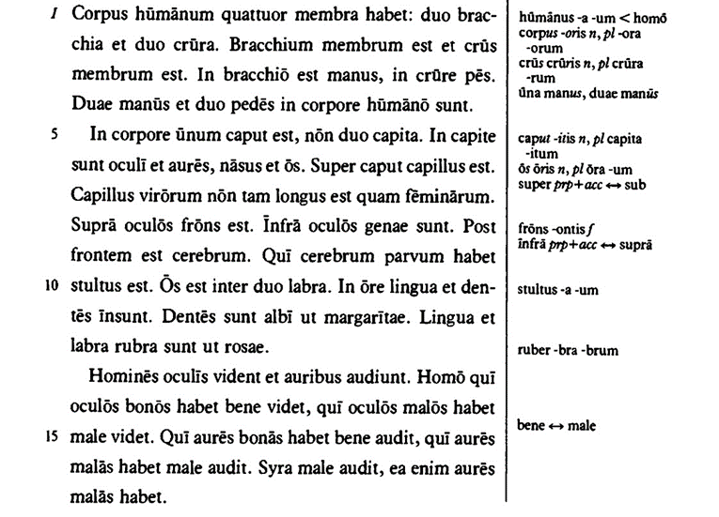

CORPUS HUMANUM
1. Suntne in corpore duo capita?
______________________________________________________
2. Quid est super caput?
______________________________________________________
3. Ubi est cerebrum?
______________________________________________________
4. Quis est stultus?
______________________________________________________
5. Quid est inter duo labra?
______________________________________________________
6. Quot membra corpus humanum habet?
______________________________________________________
7. Quid est in ventre?
______________________________________________________
8. Habet homo aeger ventrem bonum?
______________________________________________________
9. Quis est medicus?
______________________________________________________
10. ZADATAK - napravi crtež sa svim spomenutim dijelovima tijela!

CORPUS HUMANUM
1. Suntne in corpore duo capita?
______________________________________________________
2. Quid est super caput?
______________________________________________________
3. Ubi est cerebrum?
______________________________________________________
4. Quis est stultus?
______________________________________________________
5. Quid est inter duo labra?
______________________________________________________
6. Quot membra corpus humanum habet?
______________________________________________________
7. Quid est in ventre?
______________________________________________________
8. Habet homo aeger ventrem bonum?
______________________________________________________
9. Quis est medicus?
______________________________________________________
10. ZADATAK - napravi crtež sa svim spomenutim dijelovima tijela!

